Probolem1:

1.KF equations:

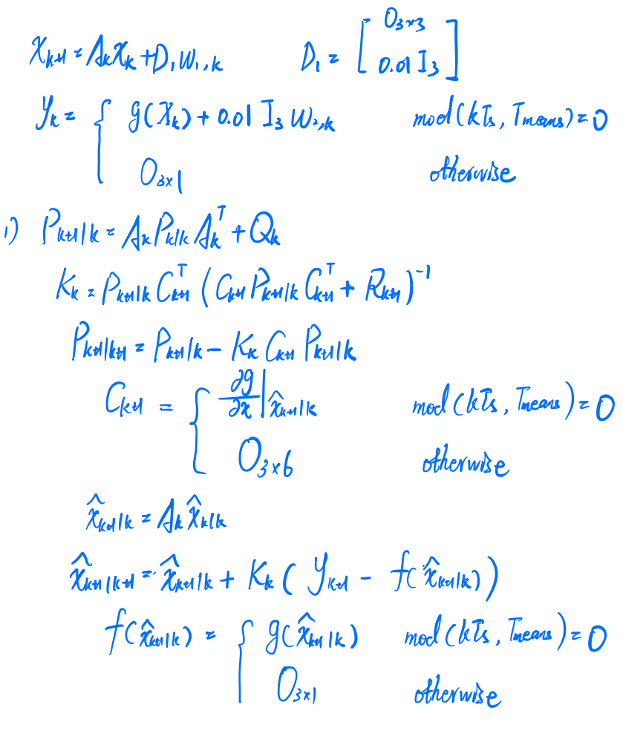

And the pictures look like below:

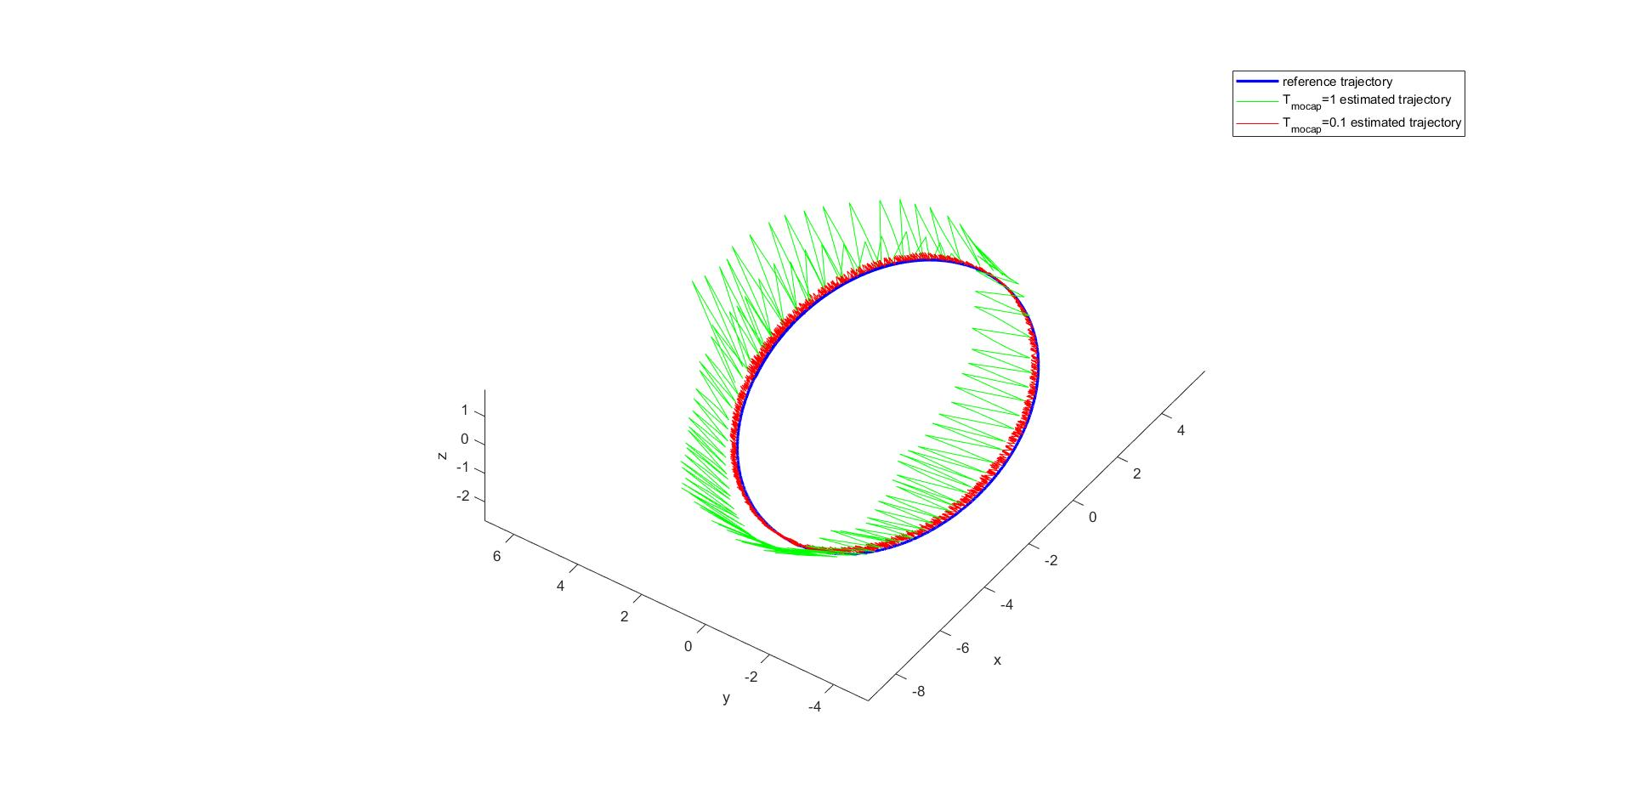

P1: trajectory of reference and estimation in 3D space

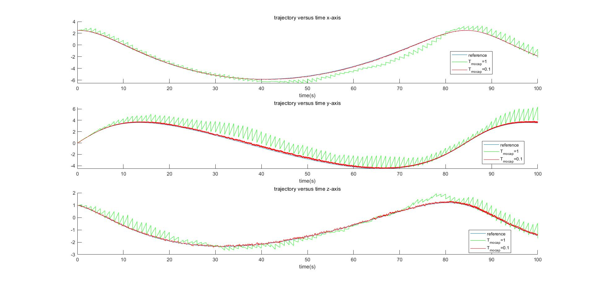

P2: trajectory of reference and estimation in 2D space

Problem2:

i)

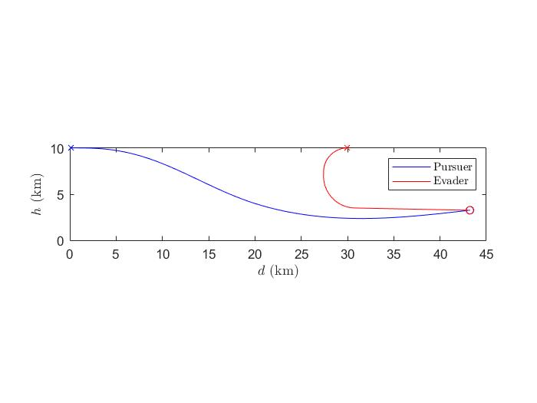P3:trajectories of the pursuer and evader for kinematics model

The miss distance is 0.8077

ii)

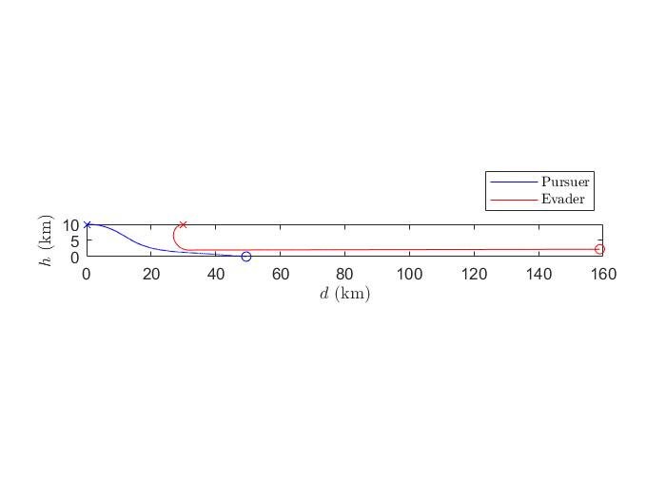

P4:trajectories of the pursuer and evader for dynamic model

The miss distance is 1.0950e+05

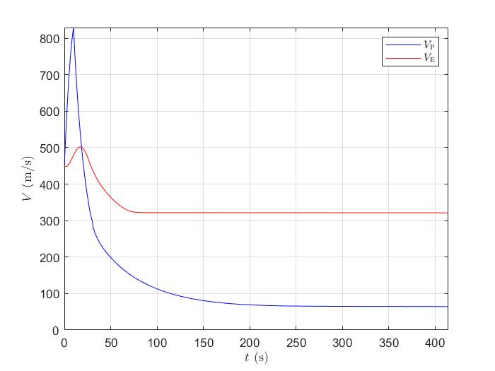

P5:Speed of the pursuer and evader for dynamic model

iii)

The miss distance of the kinematic model is very small and the distance for the dynamic model is quite large. You can consider that in the kinematics model the pursuer can catch the evader but the one in the dynamic model can not. The reason is that the kinematics model does not take thrust into consideration of acceleration. The thrust of the pursuer will finally decrease to zeros as time passes by and it makes the system impossible to meet the acceleration need for the kinematic model. In particular, the real pursuer can not maintain the velocity we set for the kinematics model because forces implemented on the pursuer have limitations.

Problem3:

i)

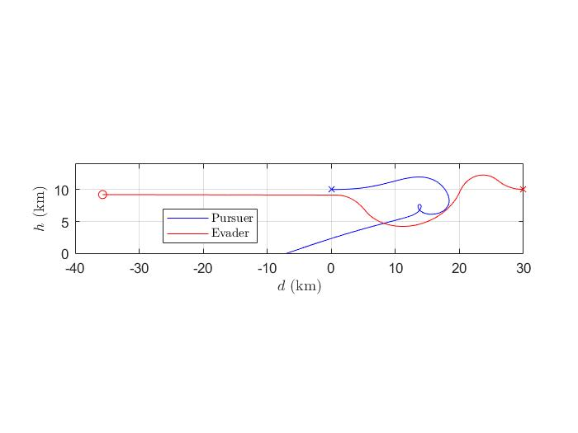

P6:trajectories of the pursuer and evader for the dynamic model in i)

The miss distance is 3.0126e+04

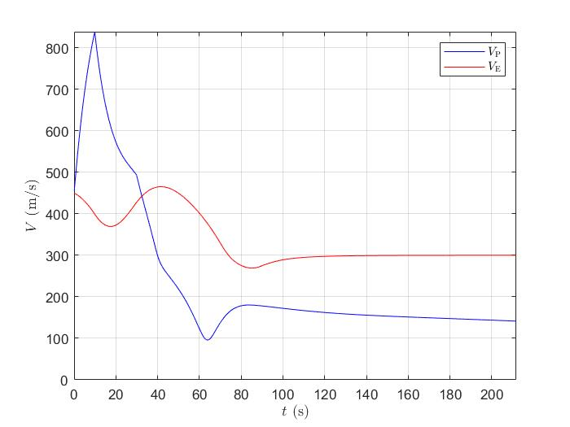

P7:Speed of the pursuer and evader for the dynamic model in i)

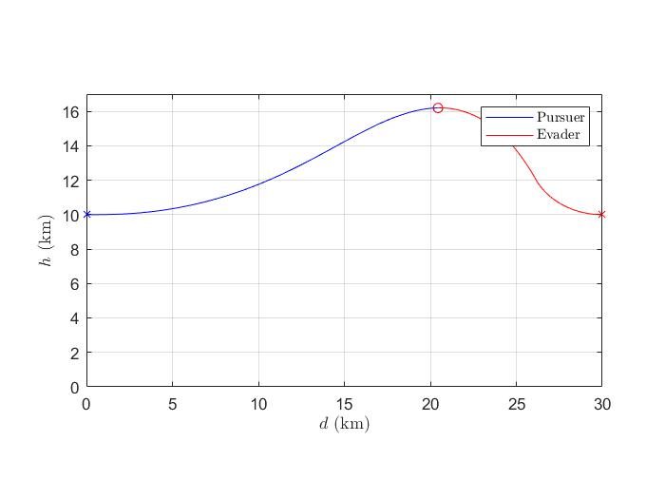

P8:trajectories of the pursuer and evader for the dynamic model in ii)

The miss distance is 9.3242e-04

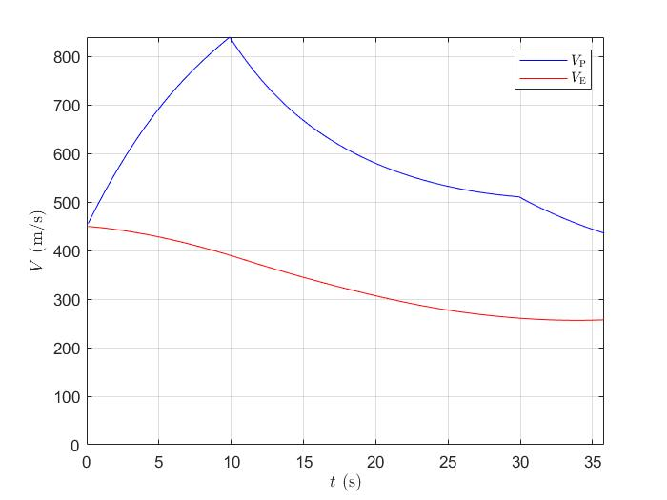

P9:Speed of the pursuer and evader for the dynamic model in ii)

Problem4:

I found that the reason for why gravity-corrected proportional guidance law fails in most case is that the trajectory of pursuer is below the evader. Our pursuer will lose most of its thrust in 10s and lose all of its thrust in 30s. As a result, we must make sure that the pursuer is above the evader after 30s, otherwise, the pursuer has to raise up when it has no thrust. Then it will lose a large amount of velocity, which makes it difficult to catch the evader. The gravity-corrected proportional guidance behaves well when the evader goes down or when the pursuer starts at a higher position, which proves my assumption. Therefore, my idea is to let the pursuer raise up quickly when it just started to make sure it become higher than the evader. As it approaches the evader, we can change to gravity-corrected proportional guidance because it should behave well if the pursuer is in a good position. And the logic of my code is below:

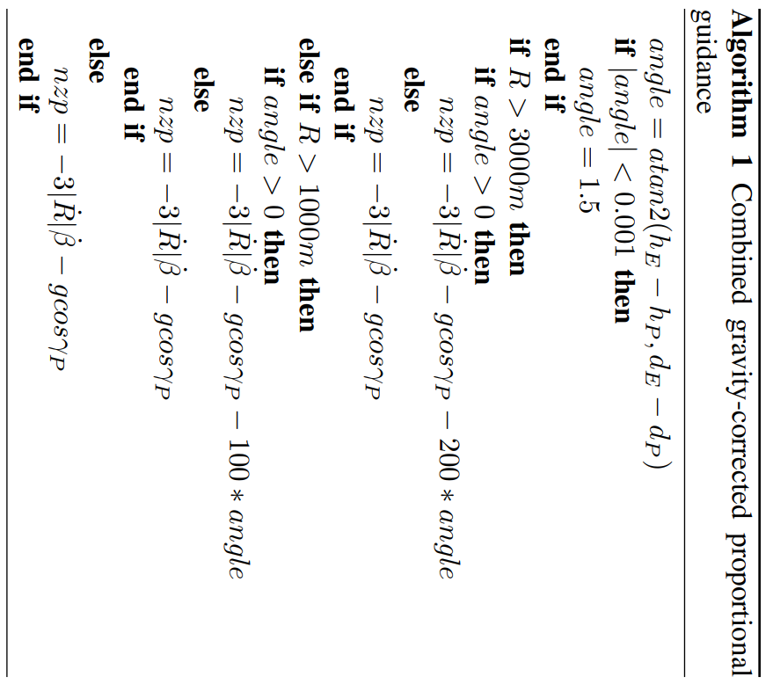

The purpose of this code is to let the pursuer go higher with a larger nzp when it is far away from the evader and below the evader. As it approaches the evader, we assume that it goes higher enough and the guidance law will degenerate to pure gravity-corrected proportional guidance law. To make my pursuer go higher at first, I add a factor related to $angle β$. If $β$ is large, which means the pursuer is below the evader, then nzp gets larger and makes the pursuer raise.

And my trajectories are shown below. My strategy successfully catch the evader 8 times, better than ordinary gravity-corrected proportional guidance law. In case 4 and case 5 we can easily see that the pursuer raises much faster than before and that’s the key to success. Even for case1 and case3 where it still fails, the miss-distance is closer than before. For now we will shift to ordinary gravity-corrected proportional guidance law if we get $angle β≤0$. We can change the hyperparameter 0 less to get the missile higher. Perhaps it will work for case1 and case3 after that.

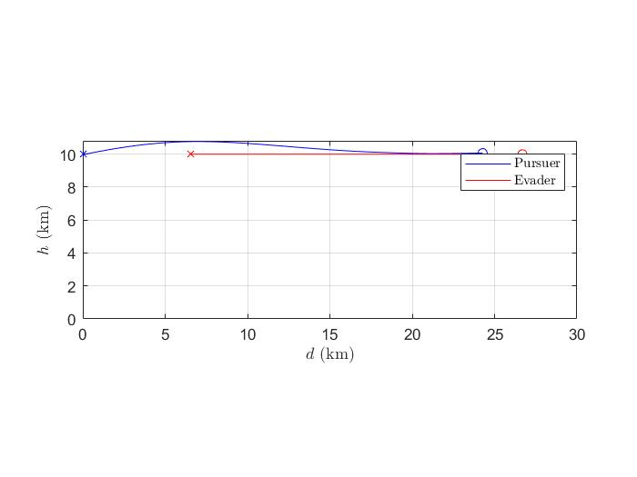

P10: trajectory for case1

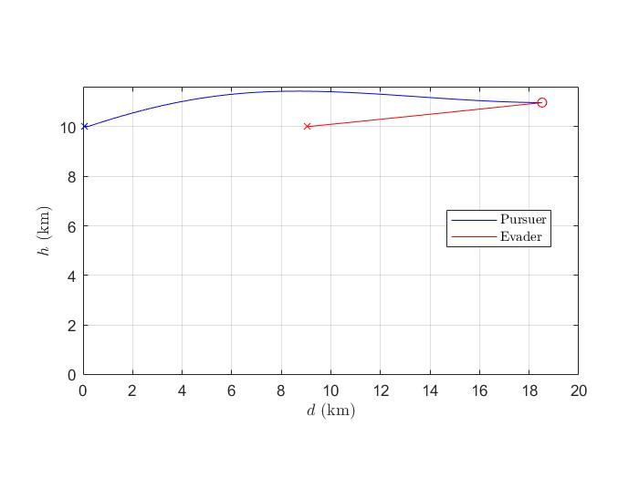

P11: trajectory for case2

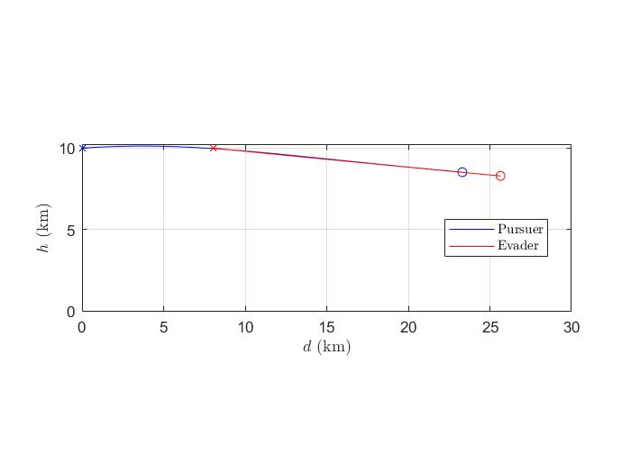

P12: trajectory for case3

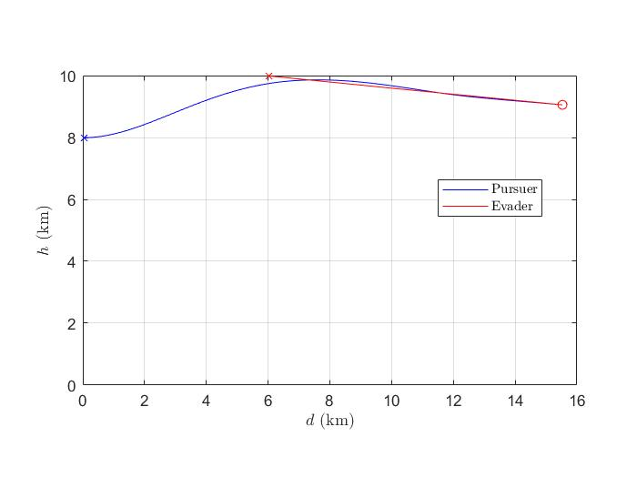

P13: trajectory for case4

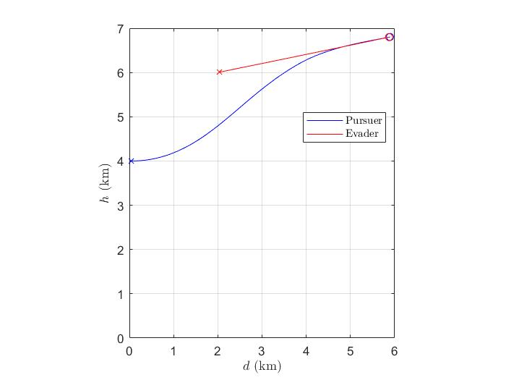

P14: trajectory for case5

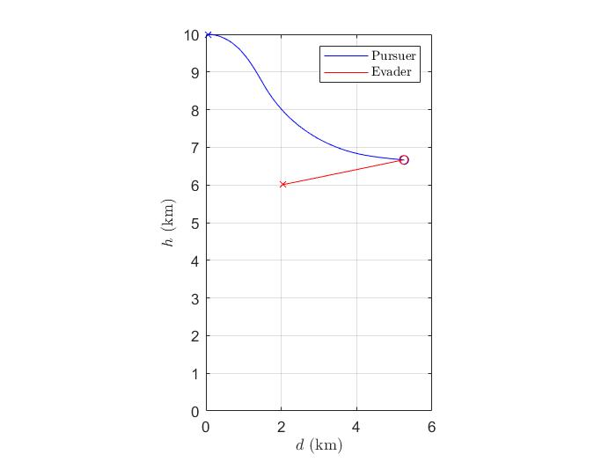

P15: trajectory for case6

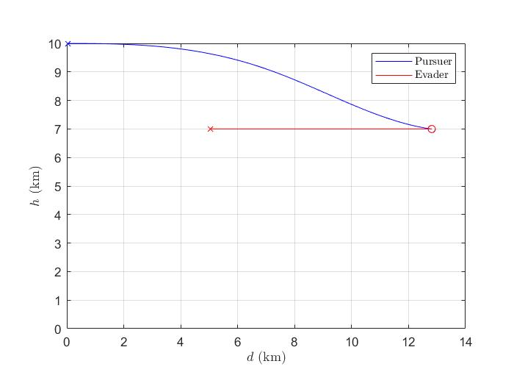

P16: trajectory for case7

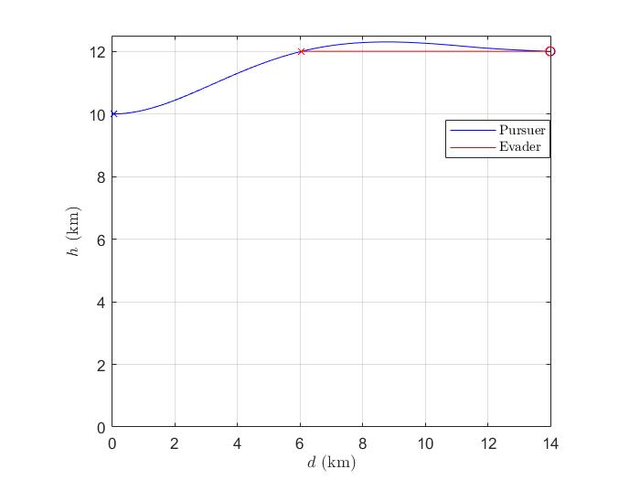

P17: trajectory for case8

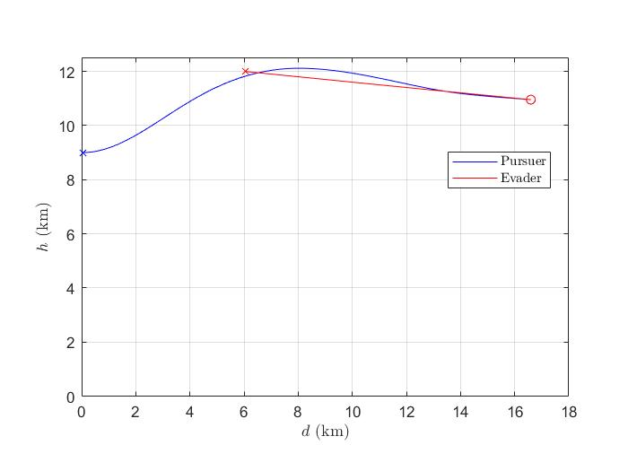

P18: trajectory for case9

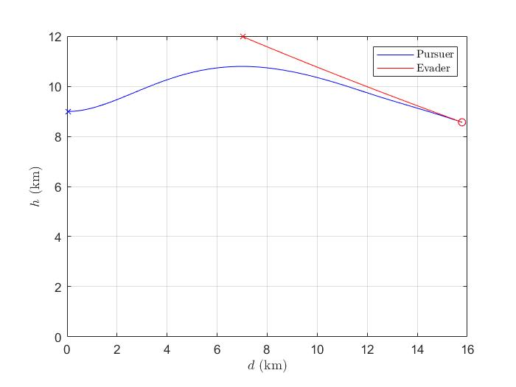

P19: trajectory for case10